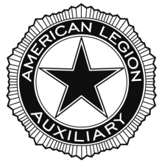
AMERICAN LEGION AUXILIARY
Department of North Carolina
Constitution and Bylaws Report Form
Deadlines: Mid Year – 12/15/19 Annual – 04/30/20
Mail to: Beth Whitaker
82 Deer Acres Drive
Horse Shoe, NC 28742
Beth28742@gmail.com

UNIT NAME AND NUMBER: ______________________________________________________
DISTRICT: __________ DIVISION: __________
PERSON COMPLETETING THE FORM_________________________________________________

1. Has your Unit reviewed your C&B? Yes No
2. Has your Unit updated your Standing Rules? Yes No
3. Has your Unit updated your Unit Policies and Procedures to conform to the National
Organization’s recent update? Yes No
4. Has your Unit had or planned a parliamentary procedure program at a Unit meeting?
Yes No If so , how many attended________
5. What year was your Unit Constitution & Bylaws last revised __________
6. Has Unit done an annual review of your Constitution & Bylaws? Yes No

