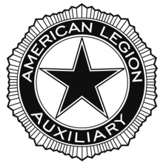
AMERICAN LEGION AUXILIARY
Department of North Carolina
Children & Youth Mid-Year Report

Chairman: Joan Master
5 Calabash Drive
Carolina shores, NC 28467
jmasters@atmc.net
Due Date: December 15, 2020
You may answer the questions below or provide a narrative to include the following:
- Number of children served
Amount of money spent
Amount of time spent

- Number of military children served
Amount of money spent
Amount of time spent
- Donation to the American Legion Child Welfare Foundation
- In your narrative please include who your unit supported
- PTSD
- The Youth Hero/Good Deed Award
- Kids of Deployed as Heros2
- How are you preparing for celebrating April as Children & Youth Month
- Any activity that your unit engaged in that provided support for children in your community and/or military children
Please provide pictures of your unit’s service to children.
Thank You

