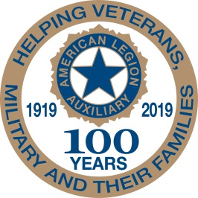
American Legion Auxiliary
Children & Youth

“Celebrating a Century of Service”
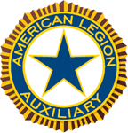

Southern Division Newsletter – July 2020

Hello ladies of the Southern Division.
Although we’re still under many constraints regarding large gatherings I am happy to read the reports that were sent it (although not required) listing all the great things you are doing in the name of our American Legion Auxiliary.
Some of your Units donated school supplies to help ease the burden on families who suffer from financial hardship. Units donated food bags for families to make sure their children receive a warm meal, others contacted the County’s School Board of Education’s social worker to see were the greatest need was.
As you can see, even with gathering limitations and social distancing we can still make sure that our children and youth are cared for.
The Auxiliary supports various scholarship programs that benefit veterans, the descendants of veterans, and The American Legion Family.

Congratulations to our Southern Division winners of Scholarships.

Spirit of Youth Award:
Marleigh Smith, Oklahoma

Children of Warriors National Presidents’ Scholarship:
Caroline Isabella Whisonant, Louisiana
Barbara Patrick, Oklahoma
Lauren Wright, Alabama

Non-Traditional Scholarship:
Veja Pronites, Arkansas

Junior Member Loyalty Scholarship:
Haley Jane Carr, Oklahoma
Anisa Grace Cornett, Texas

Please make sure you make the information regarding scholarships available to your members.

In July we are celebrating Independence Day, a holiday commemorating the Declaration of Independence if the United States, on July 4, 1776. The Continental Congress declared that the thirteen American colonies were no longer subject to the monarch of Britain, King George III, and were now united, free, and independent states. Although, the Congress had voted to declare independence two days earlier, on July 2, it was not declared until July 4.
Kids love the 4th of July because of BBQs, fireworks and more but do they know the true meaning behind this date? How can we as the American Legion Auxiliary teach our Youth about this important date in history?
1. Discuss the American Flag and flag etiquette
2. Honor our protectors - ensure the children know that there are men and women that sacrifice every
day to keep us safe
3. Sing patriotic songs like The Star-Spangled Banner, God Bless America, This Land is Your Land
etc.
I want to close this letter with an excerpt of a Whitney Houston song (The Greatest Love of All), a song we usually play at Girl State in Georgia:
I believe the children are our are future
Teach them well and let them lead the way
Show them all the beauty they possess inside
Give them a sense of pride to make it easier
Let the children's laughter remind us how we used to be
Thank you for all you do to work our programs and take care of our children and youth. These are not easy times for them and they need all the support they can get.
Stay safe.
If you have any questions or if I can be of any assistance please contact me at (706)951-3906 or barnettgabriele@hotmail.com
For God and Country,
Gabriele Barnett

